How Can Building Information Modeling (BIM) and Project Information Management (PIM) enable Smart Project Sites?

BIM has drastically improved the visualization and understanding of the project scope which has improved the decision making process in designing, executing the maintaining the constructed assets. There was also a consensus among all, the benefits that BIM has brought to the project delivery process has far exceeded the investments made in adopting BIM practices.
The Building Information Modeling (BIM) which is a combination of tools, processes, standards, knowledge and skills has eliminated many of the mistakes of uncoordinated building systems, reduced the wasted effort in developing and sharing the project scope, improved the understanding of how to build the project using 4D Scheduling, ensured better estimation of the project cost using 5D cost estimation, helped project owners in visualizing the completed project before it is built, provided valuable historical data for the facility operators and managers among many others. In summary, the message was that BIM is the way forward and there is no way back to the old practices of manual drafting or using 2D drafting software.
In reality, the BIM concept is based on the basic common sense which is to have the wisdom to make better and faster informed decisions one need to have the full knowledge of the situation where a decision needs to be made. Having the knowledge needs having the right, complete and real-time information on all related matters that are essential to build this knowledge. Having the information requires capturing the needed data correctly, by the right individuals in a timely manner.
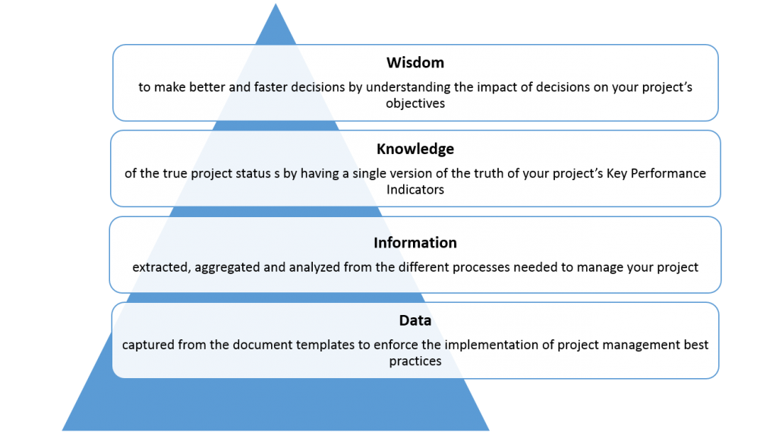
The data that can be captured in a BIM model from the different BIM objects is massive and it can be easily labelled as “BIG DATA”. The more BIM models are developed for a project, there will be more BIM objects and meta data that can be captured, this will provide better BIM information that will become available to provide more knowledge thus provide the wisdom to make better and faster informed decisions. For example, for the chart shown below, the more data is captured on the HVAC equipment as it relates to the HVAC equipment type, capacity, model, purchase price, operation cost, depreciation cost, efficiency among other, the better information will become available for the BIM model user. This will provide the knowledge and wisdom to make better and faster decisions when it come replacing this HVAC equipment with others, determine the impact on other systems, among others. The processes for capturing and reporting this data will be detailed in the BIM Execution Plan (BEP) which is a manual that will be used by the project stakeholders to develop, manage and maintain the BIM models.
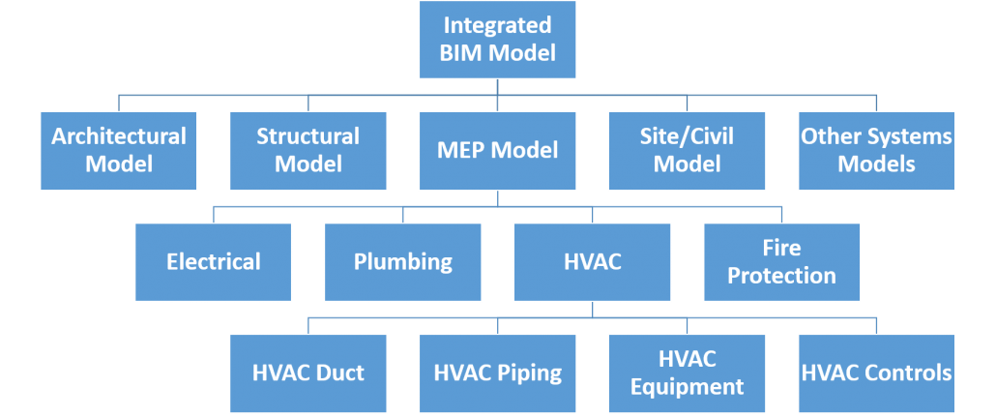
Similarly, managing a project will also result in massive volume of “BIG DATA” that relates to project scope, schedule, cost, quality, communication, risk, safety, environment, procurement among others. The project management procedures will detail the document templates that will be used to capture this data and the workflow steps to detail who will submit, review and approve this data. For example, to be able to manage the project cost, we need to manage the data associated with the project cost estimate, budget, budget revisions or adjustments, received bids, commercial bid analysis, awarded contracts, changes, progress invoices, payment of approved progress invoices and forecast to complete remaining scope. The project cost information when combined with information from the project schedule, risk, issues, safety among others will provide the decision makers with the needed knowledge to have the wisdom to make better and faster informed decisions. Of course, information can also be extracted from other solutions such Geographical Information System (GIS), Enterprise Resource Planning (ERP), Equipment and Material Sensors and Tags among others.
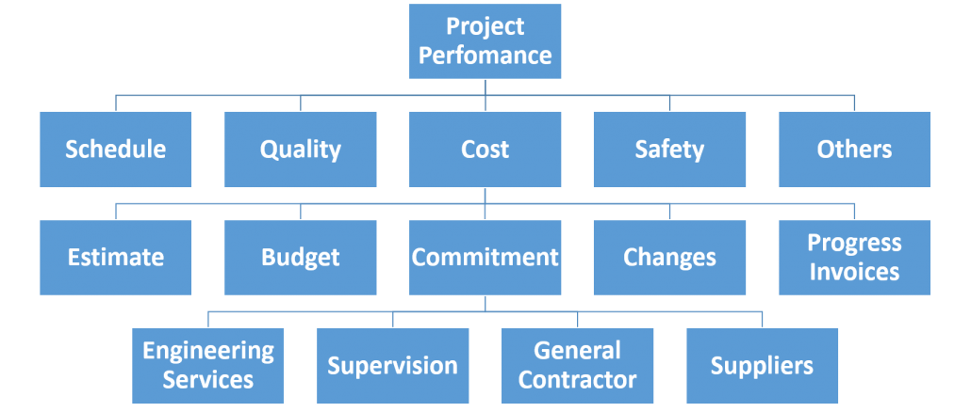
Both Building Information Modeling (BIM) and Project Information Management (PIM) data volume will grow drastically as the project progresses through the different project life stages. For BIM, this will be reflected by level of details or level of developments (LOD) that the BIM models will go through whereas for PIM this will be reflected by the increased number of project management processes that will be used to manage those stages by the current and new project stakeholders who will become part of the project delivery. Having this “BIG DATA” from BIM and PIM will provide the project team members with better platform for improving their business, make better business decisions and gain competitive advantage.
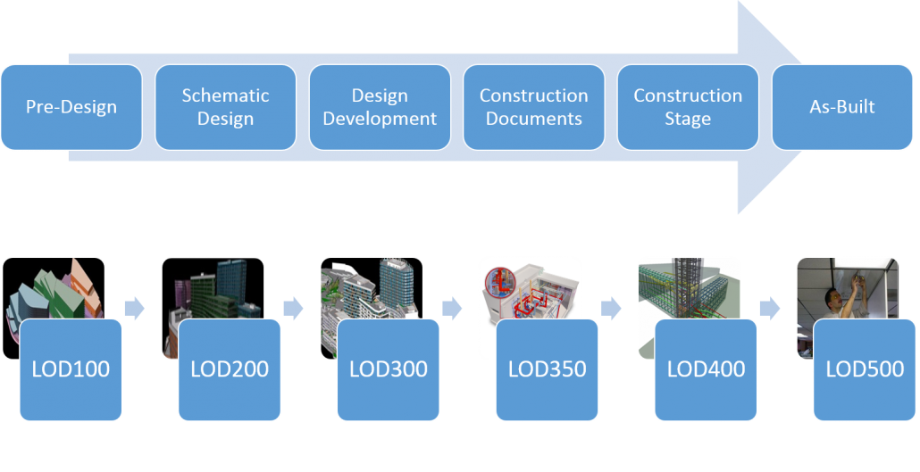
Nevertheless, one cannot stop wondering why most Project Owners, Project Management Consultants, Consultants and Contractors who have seen the great value of BIM are still reluctant in implementing the best practices of Project Information Management (PIM). Regretfully, we continue to find organizations continue capturing their valuable project’s data using manual forms and MS XLS to analyze and report the needed information. A process that we all know lacks the effectiveness, transparency, accountability and governance. Some of issues that face organizations who are using MS XLS as their Project Information Management (PIM) included:

- Introducing typos
- Have limited data validation
- Have cumbersome and costly quality control
- Have No bi-directional data exchange with the data sources
- Have Slow, non-collaborative process
- Have limited data access security
- Have data stored in Sheet Silos
- Have no data historization
- Have user manipulated reports and dashboards
- Have no audit trail
- Have no capability of capturing life data of different types from different sources

The successful adoption of BIM and PIM solutions will enable the creation of Smart Project Sites by providing project owners with massive quality, reliable, relevant and real-time “BIG DATA” that will allow project team members to better understand and interpret their projects performance. This will provide the knowledge to identify performance patterns, understand causes and propose response actions. Accordingly, those project team members will then have the wisdom to improve project management processes, make better and faster decisions and gain the competitive advantage to lead the market

