Primavera P6 EPPM vs PPM
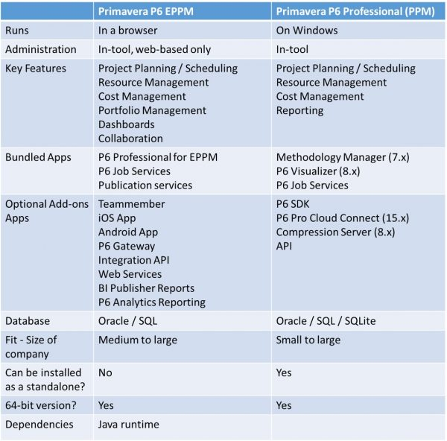
- From a scheduling perspective, Primavera P6 PPM and EPPM do the same thing.
- From a cost perspective, they are actually priced somewhat similarly.
- If you have one or two projects to schedule and work for a small to mid size company, Primavera P6 Professional is for you and your team are currently managing 30 or more projects, P6 EPPM is definitely a solution to explore.
- Primavera P6 EPPM is 100% web-based.
- Primavera P6 EPPM isn’t as robust of P6 Professional and is slow and is written on JAVA.
- Primavera P6 EPPM has a big focus on Portfolio Management, which allows you to manage groups of projects together in a portfolio, and to manage that data, be it cost, schedule or resource-focused.
- You can access and update your P6 project data on mobile apps with EPPM.

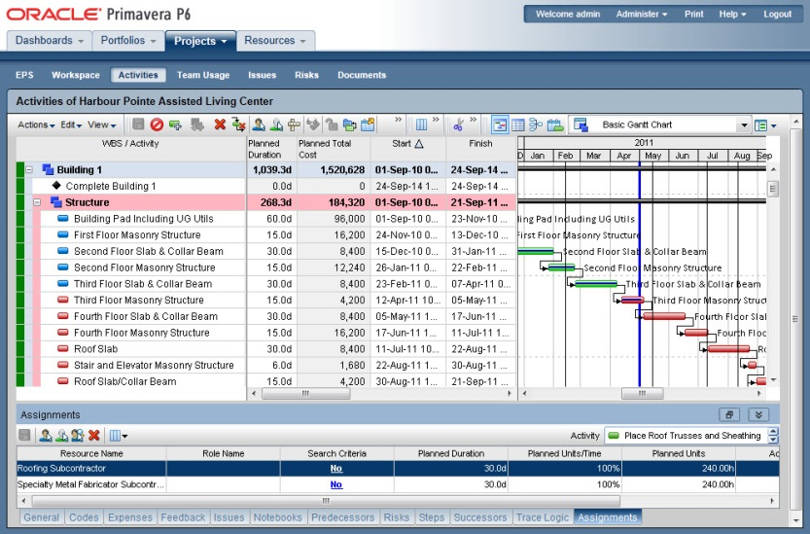Primavera P6 EPPM Screen.

