What in the World is an S-Curve? [In under 100 words]
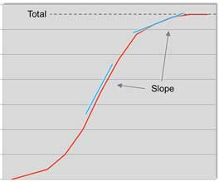
An S-curve is a graph of the expenditure of project resources over time. Typical S-curves graph either costs or resource hours over time.
The S-curve graphs the cummulative value of expenditures on the y-axis, giving the graph it’s S shape. S-curves will often graph planned values, with the actual curve overlayed for comparison.
The real benefit of the S-curve is that it shows the total value at any point in time. The shape of the S-curve can reveal important information about the trend in spending or in resource utilization.
